STEPS INVOLVED IN STARTING SIMULATION IN AIRSIM

SETTING UP ARDUPILOT-SITL:

- Go to this website:
https://ardupilot.org/dev/docs/sitl-native-on-windows.html
- Scroll down a little bit and stop on section “Installation Steps”:
- Click to install Cygwin:
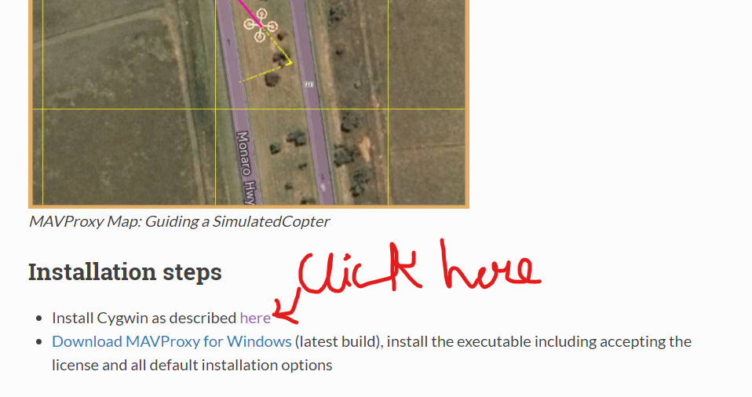

- After clicking, a new page will open there in “Install Cygwin” section
Follow step 1 shown in picture below or just click on the link
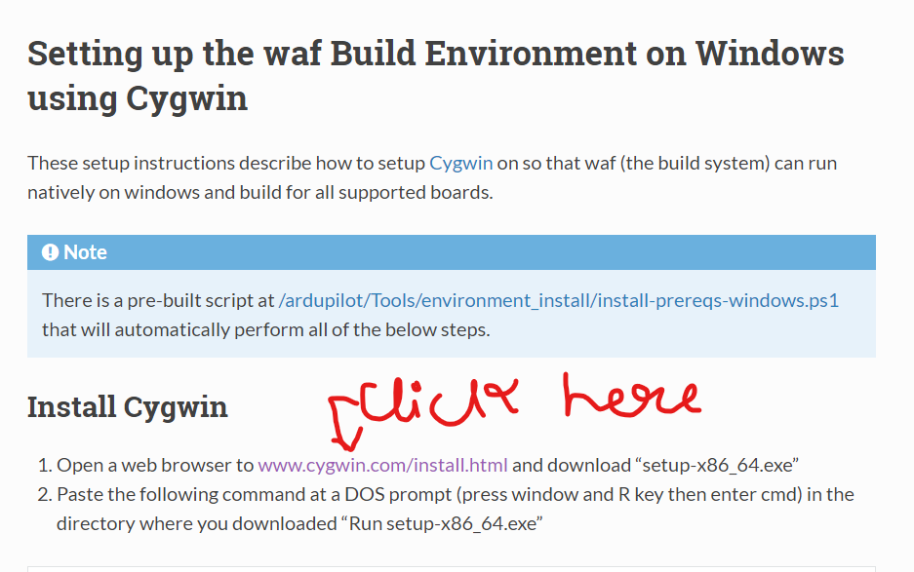
- Another page will open, there click on “setup-x86-64.exe” to download Cygwin, if you have 64-bit machine.
If you have 32-bit machine click on “setup-x86.exe”.

- Now go back to previous website

- Go to the folder where you have downloaded the .exe file in step 5.

- Open “cmd”(Windows Command Prompt) window in that folder.

- Type in the following command:

setup-x86_64.exe -P autoconf,automake,ccache,gcc-g++,git,libtool,make,gawk,libexpat-devel,libxml2-devel,python36,python36-future,python36-lxml,python36-pip,libxslt-devel,python36-devel,procps-ng
,zip,gdb,ddd

- When all the packages are selected, click through the rest of the prompts and accept all other default options (including the additional dependencies).

- Select Finish to start downloading and installing the packages.

(You can also see above steps on:
https://ardupilot.org/dev/docs/building-setup-windows-cygwin.html#building-setup-windows-cygwin)

- Now go to step 1 and 2 and there this time click on
“Download MAVProxy for Windows”(After downloading install it)

- Now go to step 4, this time scroll down to section “Set up directories/paths and extra packages in Cygwin”.

- Follow all steps shown upto “Download ArduPilot Source” section.
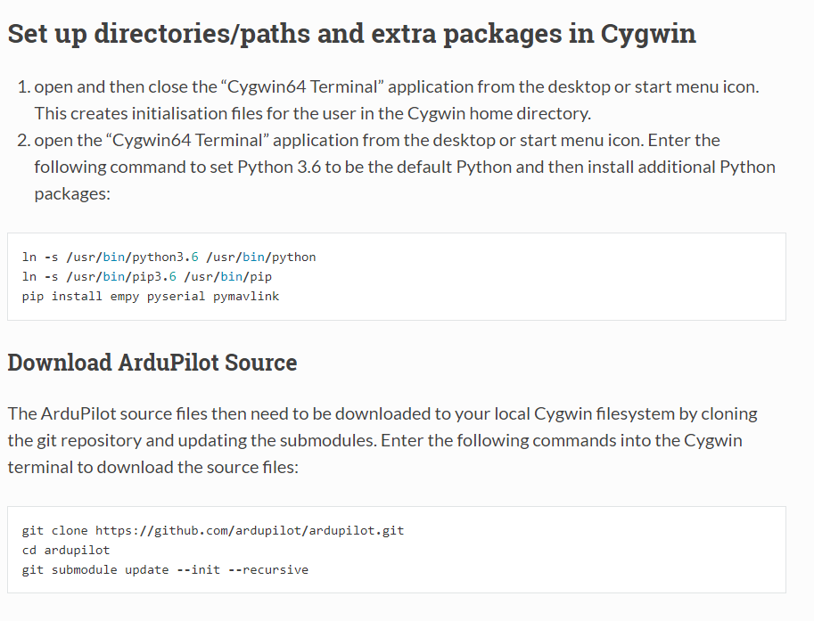
- Now open Cygwin terminal and copy- paste below commands:

>>> cd ~/ardupilot/ArduCopter

>>> ../Tools/autotest/sim_vehicle.py --map --console

- Ardupilot-SITL will start building, sit back and relax.
- If you can see a console and a map popup, you are done setting up Ardupilot-SITL

SETTING UP AIRSIM FOR USING WITH ARDUPILOT-SITL:

- Go to this website and download AirSim binaries whichever you like.
https://github.com/microsoft/AirSim/releases
- After done downloading, run AirSim at least once before going to next step.

- Go to this website:
https://ardupilot.org/dev/docs/sitl-with-airsim.html#build-on-windows

- Scroll down and follow steps in the section “Using AirSim with ArduPilot”.
Copy the settings for copter and paste it in

“C:/Users/USERNAME/Documents/AirSim/settings.json”.

You can modify “Latitude”, “Longitude” and “Altitude”.

- To do simulation first launch AirSim, then open Cygwin terminal, copy & paste the following command in the Cygwin terminal:

>>> cd ~/ardupilot/ArduCopter
>>> ../Tools/autotest/sim_vehicle.py -v ArduCopter -f airsim-copter --console –map

You can exclude the “–console” and “–map” arguments when you want to use Mission Planner instead.

When using Mission Planner, connect it through udp at localhost:14551 and execute your python scripts at udp localhost:14550

Reference video:
How to install SITL on Windows #Ardupilot #Mission Planner #MAVProxy #Arducopter - YouTube

